CS 2340, Milestone 7

**M7 – Google Map Display, Persistence, and UML Sequence Diagram**

By: **Group 18**

Section A

Summer Semester 2017

**UML Sequence Diagrams**

**User Story 1: Simola Nayak**

**User Story:** *"As a first-time user, I want to be able to register on the app, so that I can post lost or found items."*

**SUBMITTED HERSELF THROUGH T-SQUARE**

Figure I.

**User Story 2: Matthieu Capuano**

**User Story:** *“As a returning user, I want to be able to login, so that I can check the status of my lost or found items.”*

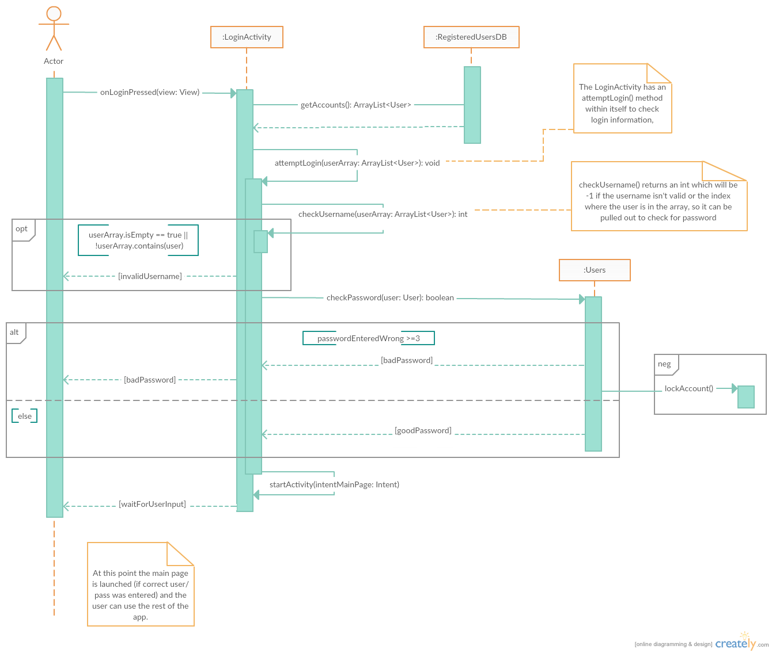

Figure II. UML Sequence Diagram for Group 18’s second User Story

**User Story 3: Sharence Solomero**

**User Story:** *“As a user who found something important, I want to be able to report it on the ‘Found Page’, so that the owner can find it.”*

**SUBMITTED HIMSELF THROUGH T-SQUARE**

Figure III.

**User Story 6: Alexander Wilkins**

**User Story:** *“As an admin, I want to be able to edit the found page and lost page and be able to remove items, so that I can remove inappropriate/Spam/old items from the list.”*

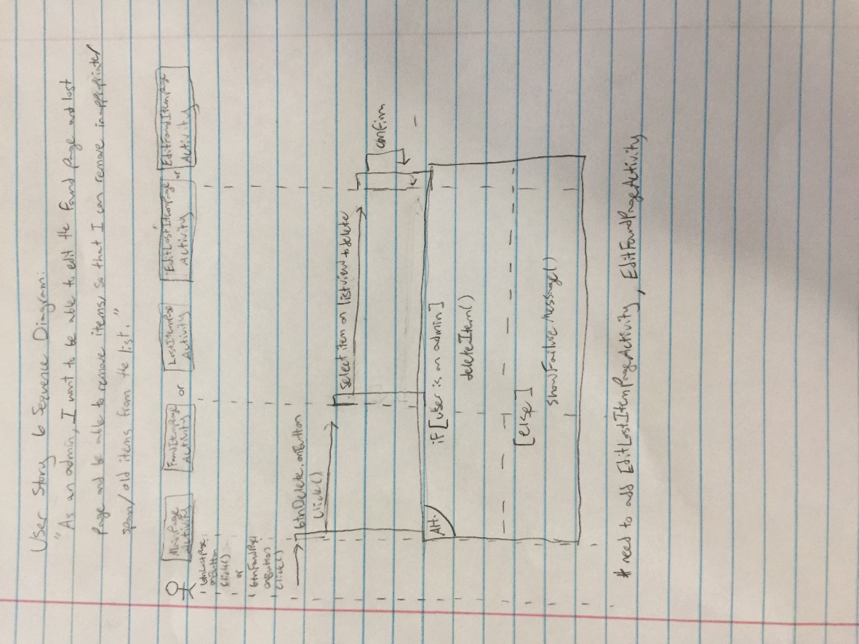

Figure IV. UML Sequence Diagram for Group 18’s sixth User Story

**User Story 7: Ash Bhimasani**

**User Story:** *"As an admin, I want to be able to look through all the users, so that I can ban ones posting inappropriate things."*

**SUBMITTED HIMSELF THROUGH T-SQUARE**

Figure V.